Accounting & Engineering: Closeout – Small Projects (TIA)

**Objective/Purpose/ Why:** Adjust process to have more timely closeout for small projects (<$20k).

**Outcome:***A better organized and simplified closeout form with timing expectations for an improved turnaround of project closeouts.*

**Subject Matter Expert: TIA Lead (Engineering), Project Accountant**

**Process:**

Step 1: When TIA, TCP, TES (Traffic Impact Analysis, Traffic Control Plan, Traffic Engineering Study) is submitted to the Agency for review, The Project manager (or staff designated by the PM) will fill out the small projects closeout form in the sections indicated in gray. Z:\Project Delivery System Policies and Procedures\6. Project Execution\Project Closeout Note, not all closeout processes can be completed at this stage.

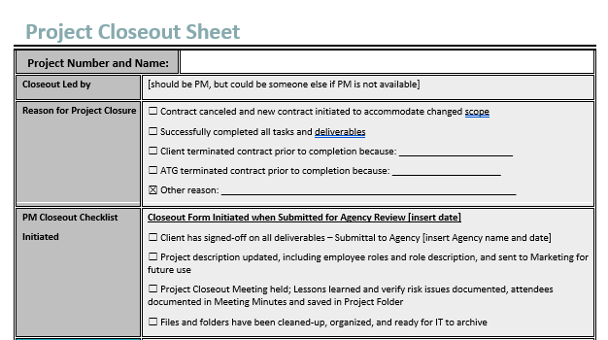

Store the Project Closeout Sheet in the project directory under /Admin/Closeout/.

Step 2: Coordinate and plan the remaining closeout duties with the Quality Manager and project staff.

Step 3: When the final Agency approval is received, the Project Manager (or staff designated by the PM) will perform the remaining closeout duties within 2 weeks of the approval.

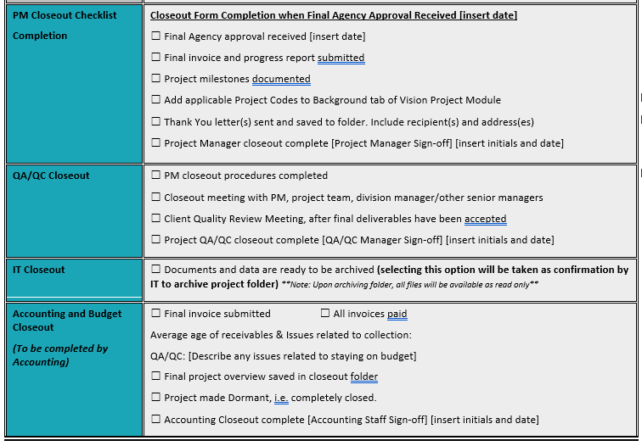

Store the completed Project Closeout Sheet in the project directory under /Admin/Closeout/. Notify Accounting of completion by email.

Step 4: Select if project is ready to Archive, Admin will contact IT. But, if the project is not ready to archive do not select and PM (designated person) is responsible for contacting IT to archive the folder at the appropriate time.

Step 5: Accounting will shut down the project as a part of the month-end close-out duties, including notifying IT to archive the project folders.

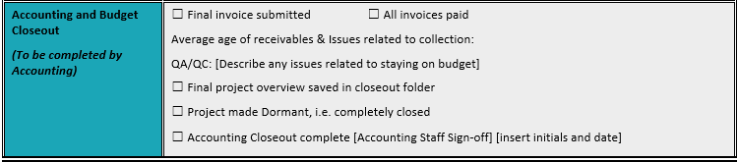

**Resources:**

Z:\Project Delivery System Policies and Procedures\6. Project Execution\Project Closeout